COMPUTER ORGANIZATION AND ASSEMBLY LANGUAGE

TOPIC:
DEALING WITH REGISTERS

NAME:
MUHAMMAD TALHA
ROLL NUMBER:
241890
SECTION:
4/A

INSTRUCTOR:
MS ROMANA MAROOF

LAB TASK 2.3
16-bit Registers with MOV and XCHG
- Initialize AX, BX, CX, and DX with different values.
- Use MOV to copy BX into AX and DX into CX.
- Use XCHG to swap AX and DX.
- Observe changes in the register window after execution.
ANSWER:
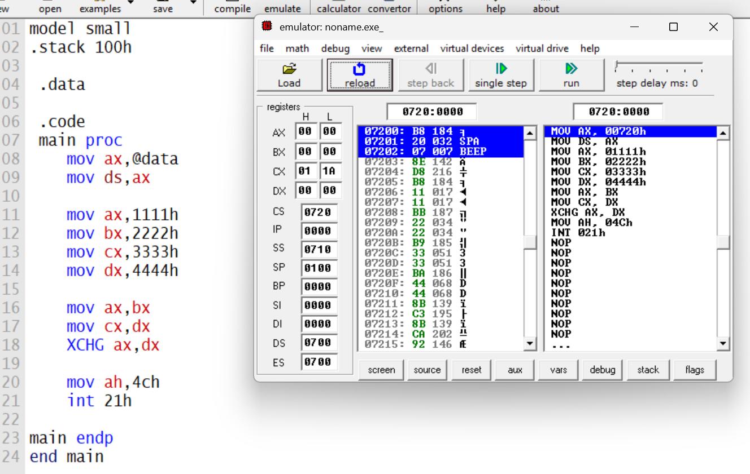
EXPLAINATION:
MOV: move mean copying values of one register to another. This just make a copy of the source into the destined register. The source register does not change and remain same.
XCHG: exchange mean swapping the values of two register with each other. In this the source value is swapped with destined value, and destined value is swapped with source value
Steps:
- value of ax is set to 1111h
- value of bx is set to 2222h
- value of cx is set to 3333h
- value of dx is set to 4444h
- value of ax becomes 2222h (copied from bx)
- value of cx becomes 4444h (copied from dx)
- value of ax becomes 4444h and dx becomes 2222h (after xchg)
- ah is set to 4ch
- program terminates via int 21h
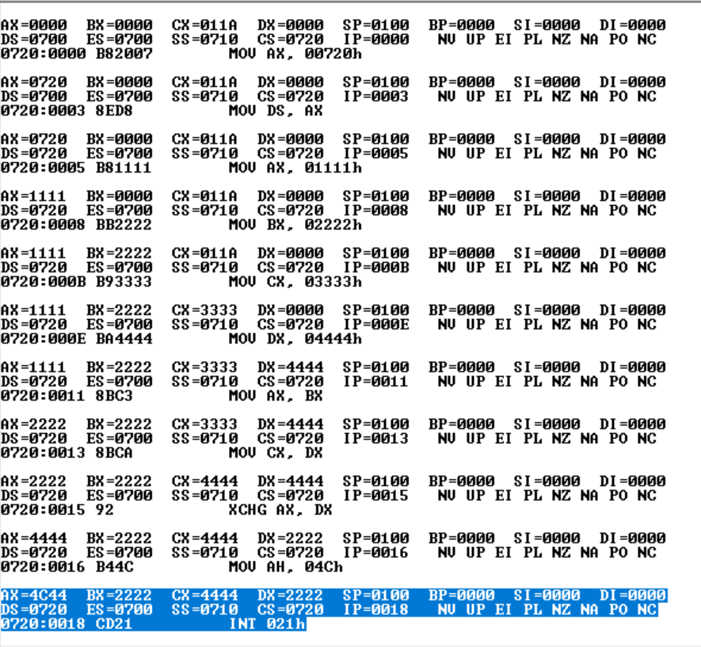
TASK 2.4:
Write a set of instructions in x86-64 assembly language that swaps the contents of upper
and lower bytes in BX register.
ANSWER:
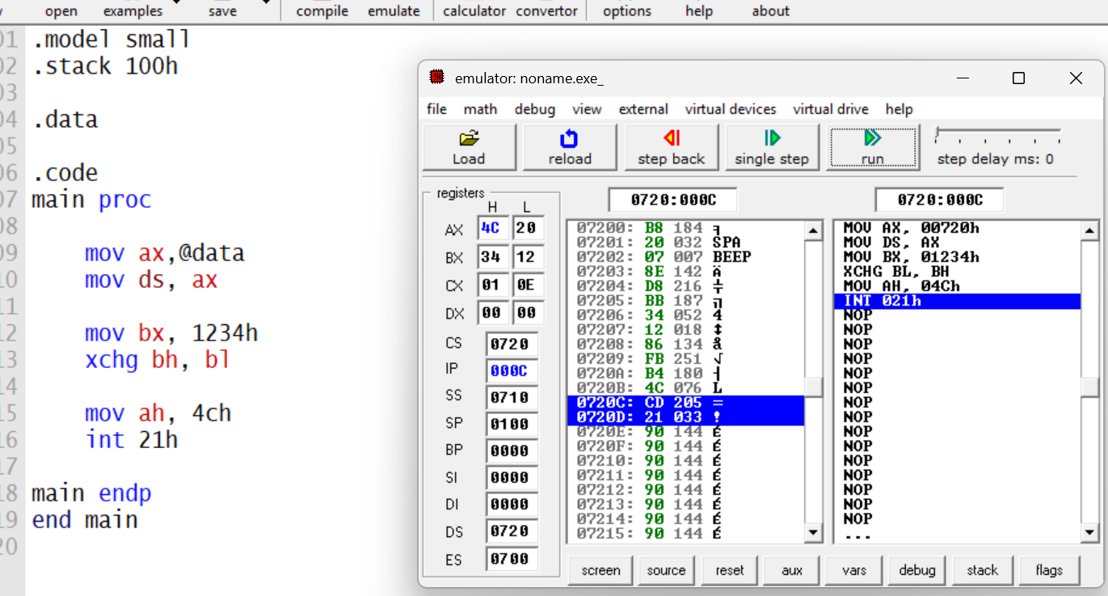
Steps:
- take the address of .data in ax
- copy it to DS
- set bx to 1234h
- exchange lower a higher bit of BX
results:
